SCOTUS — Pending Decision on DACA
Messaging Toolkit
DACA recipients play a vital role in our communities: economically, culturally and relationally. As the Supreme Court weighs its decision on the future of Dreamers, CLINIC, its affiliates and other immigration organizations must highlight the importance of DACA recipients and preemptive actions for Dreamers’ security. DACA recipients have lives in the United States. They are parents, friends, coworkers, advocates and so much more. Their #HomeIsHere.
Contents
Resources to Share: 1
Sample Posts: 3
CNN Article 4
Quick Posts 4

Hashtags: #HomeIsHere, #Faith4Daca

Resources to Share:
- #Resource: This #DACA Renewals Practice Advisory from @cliniclegal summarizes the current status of dreamers in light of pending litigation. #HomeIsHere
Read more here: bit.ly/DACA-practiceadv

- ATTN #DACA Recipients: Act today to find out how to renew your #DACA benefits. @cliniclegal has resources to connect you with legal assistance. #HomeIsHere
For more info, visit: cliniclegal.org/find-legal-help/affiliates/directory
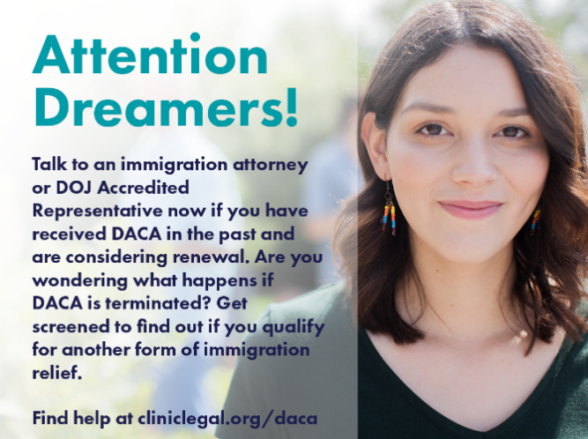

- Do you need help renewing your #DACA benefits? @cliniclegal has a directory of immigration legal services around the country. #HomeIsHere
Find legal help near you: cliniclegal.org/find-legal-help/affiliates/directory
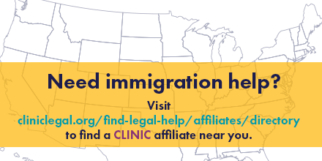

- ATTN #DACA Recipients: Use this @cliniclegal #resource to protect yourself and your community from false legal services.
Download here: bit.ly/notario_fraud

Sample Posts:
- No matter what decision comes out of the #SCOTUS, we stand in solidarity with #DACA recipients, their families and immigrants everywhere. Dreamers deserve to have their human dignity upheld. #Faith4Daca
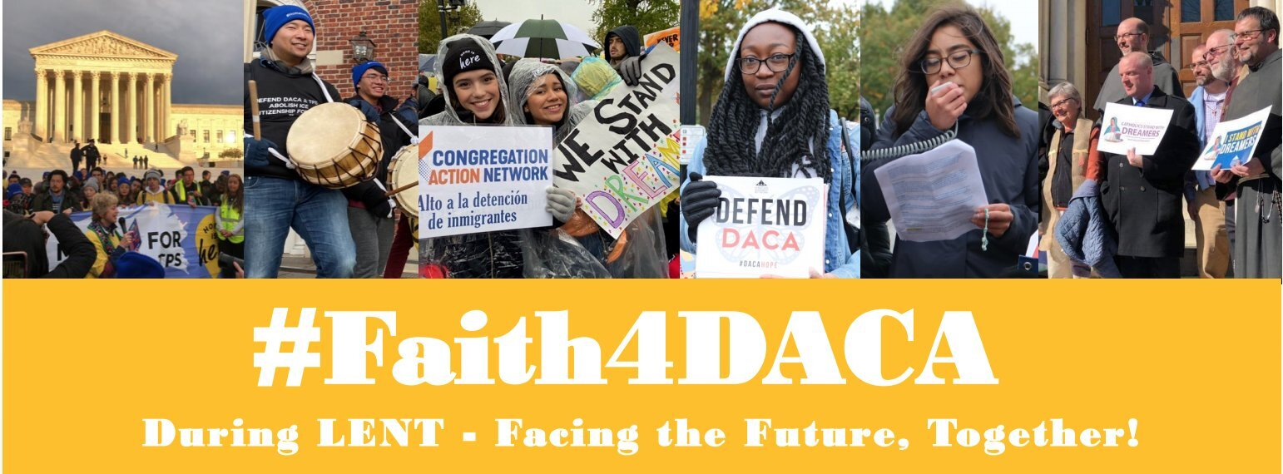

- The #SCOTUS could decide the fate of #DACA recipients any time between now and late June. Join @cliniclegal, their affiliates and immigration organizations around the country in lifting up the importance of Dreamers in our communities. #HomeIsHere
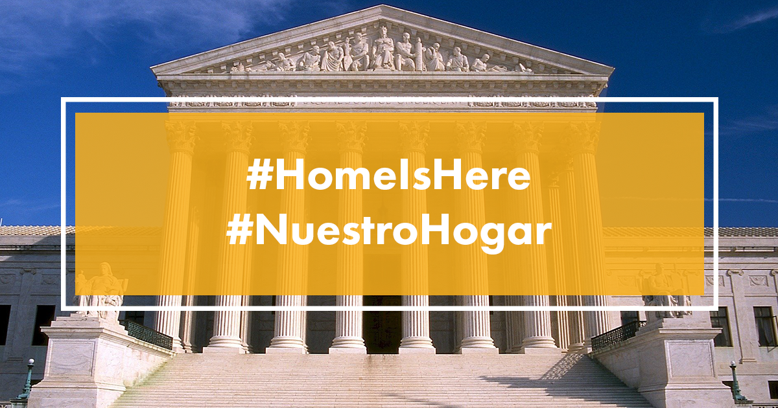

CNN Article
www.cnn.com/2020/03/27/politics/dreamers-health-care-workers-coronavirus-daca-supreme-court/index.html
- #DACA recipients have always been an important part of our communities. The 27,000+ #DACA recipients on the frontline of the pandemic are just one example of their importance. Their #HomeIsHere.
cnn.it/3dUMEQE

- A #SCOTUS decision against #DACA recipients during the #COVID19 pandemic could result in the loss of thousands of “essential” workers. These dreamers are providing on the frontlines because their #HomeIsHere.
cnn.it/3dUMEQE

Quick Posts
CLICK TO TWEET
[For reference this is the text of the click to tweet: “#DACA recipients have built lives in the United States. They are parents, friends, coworkers, advocates and so much more. Their #HomeIsHere.”]

CLICK TO TWEET
[For reference this is the text of the click to tweet: “Dreamers play a vital role in our communities: economically, culturally and relationally. As the Supreme Court weighs its decision on the future of #DACA, we stand with immigrants and their tremendous impact in our communities. #HomeIsHere”]

